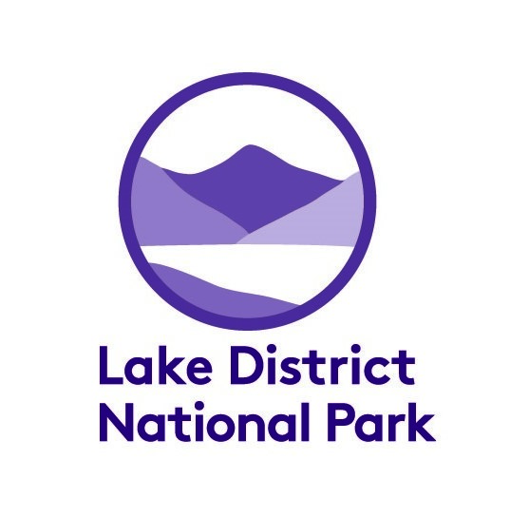

Lake District Volunteers Service
Emergency Procedure 2019/2020

What to do in the event of an emergency
Hopefully you will not need to use this procedure. However, we all know accidents happen and this procedure is here to help you.
In the event of an emergency you first need to make yourself and your group safe. If the situation is such that you need to call mountain rescue, DIAL 999/112 and ask for ‘Cumbria Police’. Once connected to the police you should request the mountain rescue service.

To report an incident, or if you need additional advice or support from LDNPA staff, please contact the following people in the following order:

Weekdays during office hours (9.00 – 5.00)
- Your Staff Supervisor
Louise Martin (01539 792659; Tues (pm), Wednesday, Thursday)
Eleanor Kingston (01539 792712); Monday, Tuesday, Thursday)
- LDNPA main contact centre 01539 724555
(they will put you through to the most relevant member of staff )

- Chris Wingrove , Volunteer Team Leader 01539 792606/07554227541
Weekends / Out of office hours
- Duty Manager ( comms) Tony Watson 07771 816746
- Head of People Carolyn Wright 07920 086655

They will be able to give you advice on what to do.

In the event of an incident, please fill out the ‘incident reporting and monitoring form’ as soon as you can after the event.

