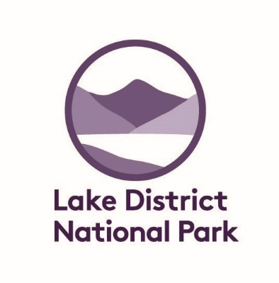



Fix the Fells Young Rangers 2019

Application and Medical Consent Form

Thank you for your interest in becoming a Fix the Fells Young Ranger.

Closing date for applications is 1st October 2019 – but places are limited and will be allocated on a first come first served basis, so apply early to avoid disappointment.

Please note, this form must be completed and signed by an applicant’s parent or guardian and returned either by email to [Annie.duckworth@Lakedistrict.gov.uk](mailto:Annie.duckworth@Lakedistrict.gov.uk) or by post to Annie Duckworth, Volunteer Recruitment Coordinator, LDNPA, Murley Moss, Oxenholme Road, Kendal, LA9 7RL

|  |  |  |
| --- | --- | --- |
| 1. Applicant’s details |  |  |
| First name: | Surname: |  |
| Preferred first name: | Date of birth: | |
| Home Address: | | |
| Email: | | |  |
| **This email will be used to send information about the programme and activities. You can provide more than one email address if you wish. At least one should be a parent/guardian email address.** | | |
| **Why are you interested in becoming a Fix the Fells Young Ranger** | | |

|  |  |  |
| --- | --- | --- |
| 2. Next of kin details | 1st Parent/Guardian | 2nd Parent/Guardian (if applicable) |
| Surname: | |  |
| First Name: | |  |
| Relationship to participant: | |  |
| Address | |  |
| Home Telephone: | |  |
| Mobile Telephone: | |  |

|  |
| --- |
| 3. Alternative point of contact details (if next of kin cannot be contacted) |
| Name: |
| Telephone: |
| Relationship to participant: |
|  |
| 4. Participant’s medical details |
| Date of participant’s last tetanus immunisation: |
| If the participant has any disabilities, medical conditions (eg. epilepsy, diabetes, asthma) or allergies we should be aware of please provide details below. Please include any specific medical advice they have been given to follow, and/or details of any medications currently used that will be taken to the Young Ranger activity (drug name/s and dosage) and may need to be administered in an emergency, Continue overleaf if necessary |
| Details: |
| If there are any other areas of the participant’s health and welfare that we should be aware of (eg. colour blindness, dyslexia, autism, Asperger’s syndrome) please provide details below. |
| Details: |

|  |
| --- |
| 5. Medical permission |
| Please tick the appropriate boxes. |
| The applicant: ❑ Can administer their own medications ❑ Will need assistance to administer their own medications |
| ❑ In the event of a medical emergency I agree to my son/daughter receiving any emergency dental, medical or surgical treatment as considered necessary by the medical authorities present. |

|  |
| --- |
| 6, Photographic Consent |
| ❑ I agree to my son / daughter being photographed / filmed on young ranger activities. These photographs / films may be used on publicity material including the Lake District National Park , National Trust and Fix the Fells websites, social media and newspaper coverage. |

|  |  |
| --- | --- |
|  |  |
| Signature of Applicant’s Parent/Guardian: | Date: |

On receipt of this form applicants will be invited to attend an Open Day on

**Saturday 12 October** .

Timings and location to be confirmed but likely to be in the Langdales / Central Lakes .

Meet staff and other Young Rangers , find out what is involved and ask any questions you may have about Fix the Fells to ensure its absolutely right for you ☺

Please circle to confirm you can attend this date

Yes I can attend 12 October

No I cannot attend 12 October