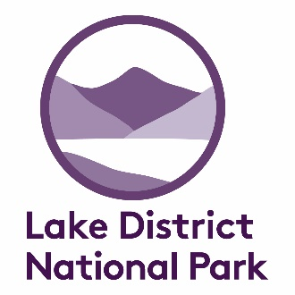

APPLICATION FOR A PERMIT TO COLLECT MINERALS
ON THE CALDBECK AND ULDALE COMMONS
(Amber Zone)

This application form should be used in conjunction with a copy of the Code of Conduct for Mineral Collecting on the Caldbeck and Uldale Commons and a map depicting the collecting zones. These are available on the LDNPA website (see end).

PLEASE COMPLETE ALL THE SECTIONS

Applicant
Name:
Address:

Postcode: Telephone:
Email:
Date of application:
Registration number of vehicle(s) to be used for the visit:

Membership of geological or mineralogical groups or societies
(Please list any relevant groups or societies of which you are a member.)

Reason for collecting
Title or summary of project:

Please continue of a separate sheet if necessary

Collecting location
Site name:
Ordnance survey grid reference: NY (8 figure)
I have marked the collecting area on a copy of the map: YES / NO
continued overleaf

Timetable
(Please provide as accurate an estimate as possible)
Date(s) of visit(s):
Total number of days collecting:
Please note that collectors in the Amber Zone must notify the LDNPA when they are on site.

Identification and storage
Name of person or institution
carrying out identification of minerals:
Position:
Address:

Postcode: Telephone:
Email:
Location where samples will be stored:

Referee
Name:
Position:
Address:

Postcode: Telephone:
Email:

Signature
I agree:
- to comply with the Lake District National Park Code of Conduct for Mineral Collecting;
- to notify the National Park Authority on all occasions when I am collecting in the Amber Zone;
- to restrict my collecting to the areas specified in this application;
- to carry my permit when collecting minerals;
- to return any collected samples to the LDNPA if so requested, for research or curation;
- to supply a short report of my activities, including identification of all mineral samples, to the LDNPA within 12 months of the end of the fieldwork.*

Signature: Date:
continued overleaf
Please note: Permits for collecting in the Amber Zone are issued to individuals for the period of one calendar year. The deadline for applications for permits in each calendar year is the end of the previous December.

Please return this form to:
Assistant Surveyor
Lake District National Park Authority
Murley Moss
Oxenholme Road
KENDAL
LA9 7RL
Telephone: 01539 724555
Email: paul.robinson@lakedistrict.gov.uk

* Further copies of this form, the map indicating Green, Amber and Red Zones and guidance on the content of reports can be found on the LDNPA website:
http://www.lakedistrict.gov.uk/learning/geology/caldbeckminerals

Updated August 2019

